Article published in:

ACSM’s Medicine & Science in Sports & Exercise
Vol. 27, No. 4, April 1995

ENERGY EXPENDITURE DURING SUBMAXIMAL
WALKING WITH EXERSTRIDERS®
Carol D. Rodgers, Jaci L. VanHeest, and Candice L. Schachter
Department of Physical Education and Exercise Science
Michigan State University, East Lansing, MI 48824-1049

ABSTRACT
This study was designed to determine whether Exerstriding, a modified form of walking using walking sticks (Exerstriders®), resulted in an augmented cardiorespiratory response and a greater energy expenditure than when walking without Exerstriders®. Female subjects (23.6 + 4.0 yr; 58.5 + 5.5 kg) completed two randomly assigned trials of treadmill walking (6.7 km/h; 0% grade; 30 min.) with Exerstriders® (E) and without Exerstriders® (C Control). Mean oxygen consumption (E = 20.5+ 1.2 ml/min/kg; C = 18.2 + 2.5 ml/min/kg), heart rate (E = 132.5 + 19.2 beats/min; C = 121.5 + 21.2 beats/min) and respiratory exchange ratio (E = .82 + .03; C = .78 + .04) were significantly greater (P< 0.05) while walking with Exerstriders®. Total caloric expenditure was also significantly greater during the Exerstrider® condition (E = 173.7 + 20.9 kcal; C = 140.7 + 27.2 kcal). In contrast, the rating of perceived exertion did not differ significantly between the two conditions. These data suggest that Exerstriding provides a means to increase caloric expenditure during submaximal walking, a factor that may be of critical importance in enhancing health benefits – such as improved body composition and aerobic capacity – typically associated with walking programs.

WEIGHTED WALKING, CALORIC EXPENDITURE, EXERSTRIDING,
HEART RATE, OXYGEN UPTAKE, PHYSICAL ACTIVITY

In light of the recent focus being placed on the health benefits of physical activity, it has become increasing more important to emphasize those activities, or forms of activity, that maximize caloric expenditure. While walking has gained increasing popularity as a form of exercise for adults today, it is often viewed as providing a limited workout. This is primarily owing to the difficulty associated with increasing the training overload of walking. Although this overload can effectively be increased by extending the duration of the walking period, a more desirable option is to increase the intensity of walking, thereby increasing caloric expenditure while at the same time maintaining the duration of the walking period.

Modifications of walking to increase intensity, and subsequent caloric expenditure, have primarily focused on the use of hand held, or ankle weights. Miller and Stamford (10) showed that adding hand weights to walking protocols of various speeds resulted in an increase in the caloric cost of walking. Graves et al. (6/7) indicated that the heart rate (HR), oxygen consumption (VO2), minute ventilation (VE), and respiratory exchange ratio (RER) were all elevated during periods of “weighted” walking in contrast to similar time periods of “nonweighted” walking. The 1 MET (1 MET = oxygen consumption of 3.5 ml/kg/min: metabolic equivalent) increase in energy cost that was observed while carrying 1.36 kg (3.09 lbs) hand weights or wrist weights was found to represent a 14.3% increase in total energy demand over the non-weighted exercise bout. Claremont and Hall (5) demonstrated increases in energy expenditure between 5% and 8% in subjects who ran on a motor driven treadmill (0% grade; 8.9-13.7 km/h) for 30 minutes under one of three conditions: carrying hand weights, wearing ankle weights, or using hand and ankle weights. In contrast when assessing walking with weights of 0.45, 1.36, or 2.27 kg per hand at 4.8 km/h or 6.4 km/h and 4% grade, Owens et al. (11) failed to show any significant change in HR, VO2, RER or rating of perceived exertion (RPE). The difference in findings between these two studies is most likely owing to the different exercise intensities used.

Exerstriding is a modified form of walking that incorporates the use of specially designed walking sticks (Exerstriders®) in a standard walking workout. Training with Exerstriders® has been shown to increase upper extremity muscular endurance (0); however, to date, there is limited information examining the effect of Exerstrider® use on overall energy expenditure during moderate intensity walking. It stands to reason that the enhanced used of the upper body musculature necessitated by using the Exerstriders® would result in an increase in exercise intensity and an overall increase in energy expenditure during the walking activity. In light of recent research stressing the importance of total caloric expenditure in physical activity programs (2,3), Exerstriding offers a potential means by which to attain an enhanced expenditure in a common activity such as walking. Moreover, individuals previously limited by balance/stability problems and/or orthopedic pathologies may benefit from the support provided by the Exerstriders® and may now be able to participate in a walking program. This would allow them to achieve improved levels of fitness that they might have been otherwise prevented from attaining.

It was therefore the purpose of this study to evaluate the effects of the use of Exerstriders® on cardiorespiratory parameters during a single bout of submaximal treadmill walking and to compare the data obtained with data from a similar bout of exercise without Exerstriders®.

METHODS

Subjects

Ten moderately active females volunteered to participate in this study. In accordance with Michigan State University Use of Human Subjects guidelines, each subject was informed of the requisite testing procedures and the potential risks associated with these procedures prior to providing written informed consent to participate. All subjects were trained in correct use of the Exerstriders® during walking before beginning the study. A maximal oxygen uptake test (multistage test; 2 min workloads; constant speed of 6.7 km/h; grade increments of 2% until exhaustion) was administered to each subject 1 week prior to the beginning of the study.

Protocols

Each subject completed two randomly assigned trials of treadmill walking (6.7 km/h; 0% grade; 30 min duration), once with Exerstriders® (E) and once without Exerstriders® (C), The average weight of each of the Exerstrider poles was 13-14 ounces. Throughout each exercise trial, expired air was collected for 2 min periods in Douglas bags, using open circuit spirometry technique. Expired air was pumped through a calibrated dry gas volumeter, measured, and corrected for the volume of air that was simultaneously being drawn through the gas analyzers. The fractional concentration of oxygen and carbon dioxide in the expired air was determined using Applied Electrochemistry (American Meter Co., Singer), oxygen (model # S-3A), and carbon dioxide analyzers (model CD-3). Oxygen uptake (VO2 ml/min/kg) was calculated using standard formulas with corrections for respiratory tubing dead space, volume pump dead space, and gas volumeter temperature. RER (VCO2/VO2) for each of the 2 min work periods was also calculated and subsequently used to compute the total caloric expenditure (TKCAL) for the total 30 min walking period. A modified CM-5 lead placement arrangement was used to continuously monitor heart rhythm for the duration of each test. Heart rate (Burdick Instruments, Milton, WI) was recorded during the last 10 s of each 2 min measurement period. An RPE was also obtained every 2 min using the original (6-20) Borg Scale (4). Test sessions were separated by a 48 h rest period and were conducted at the same time of the day to minimize the effects of diurnal variation.

Statistical Analysis

Repeated measures analysis of variance techniques (12) were used to test for differences in heart rate, oxygen uptake, and RER at each 2 min collection period between the two walking conditions (E and C). Significant pair-wise differences were determined using the Scheffe post-hoc test. Average oxygen uptake, average heart rate, and average RER for the total 30 min period were also computed for each condition, and subsequent differences between means were compared using a paired t-test. Total caloric expenditure was also compared between the two conditions using a paired t-test. The level of significance was chosen at P < 0.05 in all instances. All values presented are expressed as mean + SEM.

RESULTS

The subjects were 10 moderately active females (23.6 + 4.0 yr; 58.5 + 5.5 kg) with an average maximal oxygen uptake of 45.6 + 5.6 ml/min/kg.

As can be observed in Figure 1, Exerstrider® walking, elicited a significantly greater (P < 0.05) oxygen consumption (ml/min/kg) during the first 14 min of the exercise bout, during minute 22, and during minutes 28-30. The average oxygen consumption for the total 30 min exercise period was significantly greater when walking with Exerstriders® than when walking without Exerstriders® (E = 20.5 + 1.2 ml/min/kg; C = 18.3 + 2.5 ml/min/kg).

Heart rate (beats/min) was not found to be significantly different between the two conditions at any singular time point examined, although the tendency was for Exerstrider® walking to elicit a higher heart rate throughout the total 30 min period (Fig.2). The average heart rate of 132 + 19 beats/min achieved over the total 30 min period of Exerstrider ® walking was significantly greater than the average heart rate of 121 + 21 beats/min achieved during the control condition.

The pattern of RER response during the 30 min walking period is displayed in Figure 3 for both conditions. RER was found to be significantly greater when using Exerstriders® at minutes 2-4, 10-14, and 18-24. When assessed across the total 30 min walking period, the average RER of 0.82 + 0.03 that was achieved during the Exerstrider® condition was found to be significantly greater than the average RER of 0.78 + 0.04 achieved during the control condition. Total caloric expenditure while walking with Exerstriders® was significantly greater than that achieved while walking without Exerstriders® (E = 173.7 + 20.9 kcal; C = 140.7 + 27.2 kcal). RPE was not significantly (P > 0.05) different between the two conditions.

DISCUSSION

This study was designed to determine whether walking with Exerstriders® would increase the energy cost of walking at 6.7 km/h on a level grade. It was hypothesized that use of the arms as necessitated by pole gripping, planting, and swing through in Exerstrider® walking would result in a greater energy expenditure than would be required when walking without Exerstriders®. The data from this study indicated that over a 30 min period of treadmill walking at 6.7 km/h (0% grade), average HR, VO2, and RER were greater when walking with Exerstriders® than when walking without Exerstriders®. This would suggest that incorporating Exerstrider® use into a regular walking program can enhance the physiological benefits of the exercise program. The elevated oxygen consumption and resultant increase in caloric expenditure that was observed during Exerstriding are indicative of an increase in the energy cost of the exercise. For individuals who are participating in the regular walking program, adding Exerstriders® to their regular workout would serve to enhance the intensity of their workout and thus, in the same given time period, would increase the caloric expenditure. Many individuals who participate in a walking program are doing so not only to improve cardiovascular fitness but also to decrease body weight. Creating a greater negative energy balance within the same exercise time frame is a positive attraction of Exerstrider® use.

The increase in energy expenditure (0.643 METS) that was observed when Exerstriding was comparable to that observed when walking with ankle (8) or 9.45 kg hand weights (6.0 km/h; 7.9% grade) (6). Greater MET increments have been shown to occur when walking with 1.36 kg wrist and hand weights (6,7), suggesting an important role of the amount of weight added in the observed energy increment. Average heart rate was increased 10 beats/min when walking with Exerstriders®. These data are comparable to those of Graves et al. (6.7), who examined subjects walking (6.3 + 0.25 km/h at 6.3 + 1.4% grade) with 1.36 kg ankle, wrist, or hand weights and demonstrated heart rate elevations of 7, 9 and 13 beats/min, respectively. Although this elevation in heart rate is greater than would be expected from the change in oxygen consumption, it is likely that this is a reflection of the static upper body muscular component required during Exerstriding and does not truly represent an upward shift in the linear relationship between heart rate and oxygen consumption. When walking with Exerstriders®, the average caloric expenditure was 5.8 + 0.2 kcal/min. This is greater than or similar to the energy expenditure observed while walking with ankle or hand weights (2.25 kg) at 2 mph and similar to that observed for weighted (2.25 kg) ankle walking at 3 mph (10).

Although the arm action of Exerstrider® walking more closely resembles the pumping action recommended by Auble et al. (1) to achieve greater energy expenditure while walking with hand weights, the increase in energy expenditure was not comparable. It is likely that either a) the weight of the poles (13-14 ounces/pole) that are moved through this range of motion while Exerstriding is not of a great enough consequence to cause a more significant increase in energy expenditure or b) the vigor of pumping is more significant than the planting and subsequent movement of the Exerstrider® poles. Thus, it would seem from these data that the increase in energy cost observed with Exerstrider® use is similar to that seen when walking with ankle weights or very light (0.45 kg) hand weights.

It is important to note that the evaluation of Exerstrider® use was done on a motorized treadmill, a factor that in itself may have affected energy expenditure. Since the pole was planted on the treadmill belt, the movement of the treadmill belt may have contributed to the work of moving the pole across the ground and “poling off”. It is conceivable that the observed difference in energy cost was lower than that which might have been observed had the subjects been walking on level ground and been able to more effectively use their upper body to aid in pole propulsion.

The potential for biomechanical/orthopedic problems that may arise as a result of extensive use of hand weights, particularly when efforts to increase energy expenditure are elicited by significant arm pumping (11) has been identified as a potential limitation of use of this type of energy “enhancing” devise. Since Exerstriding involves the use of poles lighter than most hand and wrist weights and involves a more natural pattern of arm action, it may be less likely that these types of overuse injuries would occur. Furthermore, individuals whose intensity of activity is limited by lower extremity orthopedic problems might benefit not only from the increased energy expenditure provided by Exerstriding but also from the increased stability provided by use of the poles. Elderly persons who choose not to walk because of concerns about uneven terrain and balance may also be more encouraged to participate in a walking program.

In summary, Exerstrider® use during a 30 min period of submaximal treadmill walking (6.7 km/h; 0% grade) resulted in an increased HR, VO2, RER, and caloric expenditure when compared with walking without Exerstriders®. Although the observed increase in energy expenditure was small, recent evidence suggests that a) total energy expenditure may bee an integral factor in the achievement of the protective benefits of physical activity and fitness (2,3) and that b) further emphasize the importance of this modified form of walking as a means by which individuals can develop both cardiovascular and upper body muscular fitness. Additional studies are needed to determine the blood pressure response of different population groups to Exerstriding and to determine the long-term effects of training with Exerstriders® on various physiological parameters.
Figure 1 – Oxygen consumption (ml/kg/min) during 30 min of submaximal walking with and without Exerstriders®. Data are presented as mean SEM. *Exerstrider® values were significantly (P, 0.05) greater than Control.

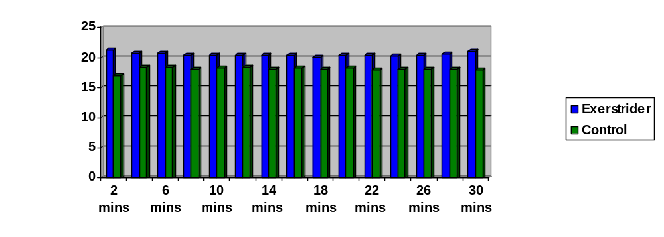

Figure 2 – Heart rate during 30 min of submaximal walking with and without Exerstriders®. Data are presented as means SEM. No significant differences were observed between the two conditions.
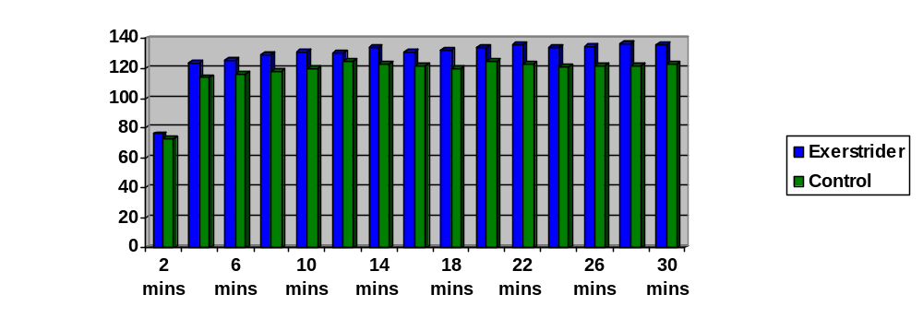
Figure 3 – RER during 30 min of submaximal walking with and without Exerstriders®. Data are presented as means SEM. *Exerstrider® values were significantly (P< 0.05) greater and Control.
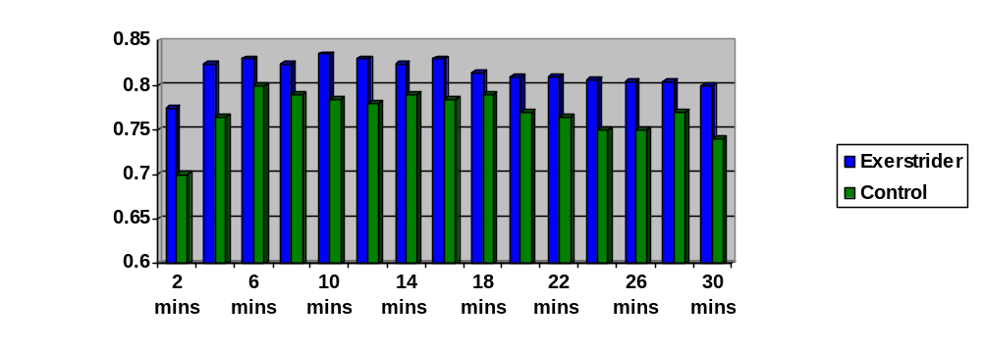

REFERENCES

- Auble T.E., L. Schwartz, and R.J. Robertson. Aerobic requirements for moving handweights through various ranges of motion while walking. Phys. Sports Med. 15:133-140, 1987.

- Blair S.N., H.W. Kohl, N.F. Gordon, and R.S. Paffenbarger. How much physical activity is good for health? Annu. Rev. Public Health 13:99-126, 1992.

- Blair S.N., H.W. Kohl, and N.F. Gordon. Physical activity and health: a lifestyle approach. Med. Exerc. Nutr. Health 1:54-57, 1992.

- Borg, G.A.V. Psychological bases of perceived exertion. Med. Sci. Sports Exerc. 14:377-387, 1982.

- Claremont, A.D. and S.J. Hall. Effects of extremity loading upon energy expenditure and running mechanics, Med. Sci. Sports Exerc. 20:167-171, 1988.

- Graves, J.E., M.L. Pollock, S.J. Montain, A.S. Jackson, and J.M. O’K. The effect of hand-held weights on the physiological responses to walking exercise. Med. Sci. Sports Exerc. 19:260-265, 1987.

- Graves, J.E., D. Martin, L.A. Miltenberger, and M.L. Pollock. Physiological responses to walking with hand weights, wrist weights, and ankle weights. Med. Sci. Sports Exerc. 20:265-271, 1988.

- Jones, B.H., M.M. Toner, W.L. Daniels, and J.J. Knapik. The energy cost and heart rate response of trained and untrained subjects walking and running in shoes and boots. Ergonomics 27:895-902, 1984.

- Karawan, A., J.P. Porcari, N.K. Butts, S.M. Postmus, L. Stoughton, and J. Larkin. Effects of 12 weeks of walking or Exerstriding on upper body strength and endurance (Abstract). Med. Sci. Sports Exerc. 24:S138, 1992.

- Miller J.F., and B.A. Stamford. Intensity and energy cost of weighted walking vs. running for men and women. J. Appl. Physiol. 62:1497-1510, 1987.

- Owens, S.G., A. Al-Ahmed, and R.J. Moffatt. Physiological effects of walking and running with hand-held weights. J. Sports Med. Phys. Fitness 29(4):384-387, 1989.

- Statview® Se+ Graphics. The Solution for Data Analysis and Presentation Graphics. Berkeley, CA: Abacus Concepts, In., 1987.

